**Advance Excel Assignment 1**

1. What do you mean by cells in an excel sheet?

**Solution:**

A cell is an object in an Excel sheet for entering information.

This is represented by the column name followed by the row number.

The address of the first cell in the Excel sheet is **A1** (A is the first column of the Excel sheet and 1 is the first row). The format of the Excel spreadsheet looks like a table, and the intersection of rows and columns formats blocks (boxes). **Each of these small blocks is called a cell in Excel.**

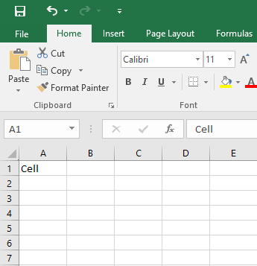

Non-Editable Mode

Press F2 function key to make the cell editable

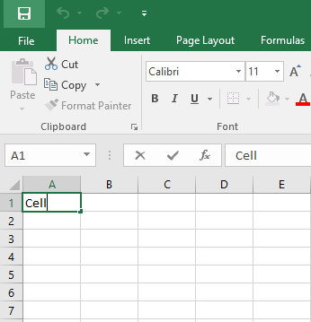

Editable Mode

2. How can you restrict someone from copying a cell from your worksheet?

**Solution:**

To protect the worksheet from copying the cell values, need to follow the below steps.

**Step 1:** Open the excel and select the sheet then navigate to Review Tab from the Menu bar

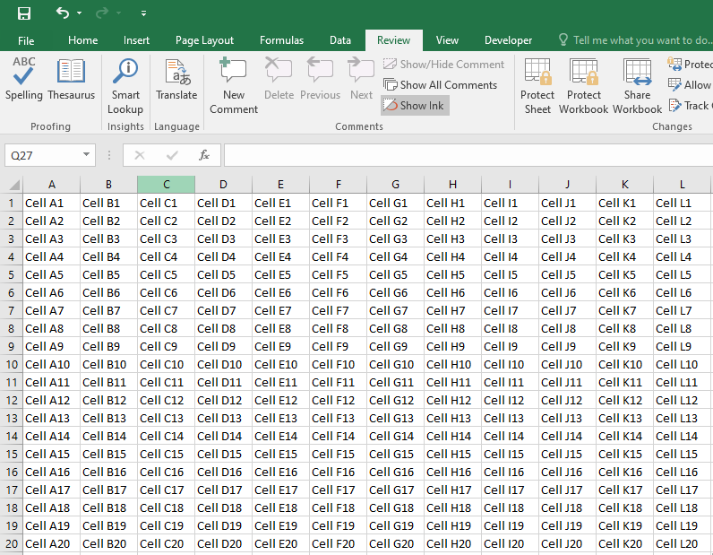

**Step 2**: Click on Protect Sheet icon and Protect Sheet dialog window should be displayed

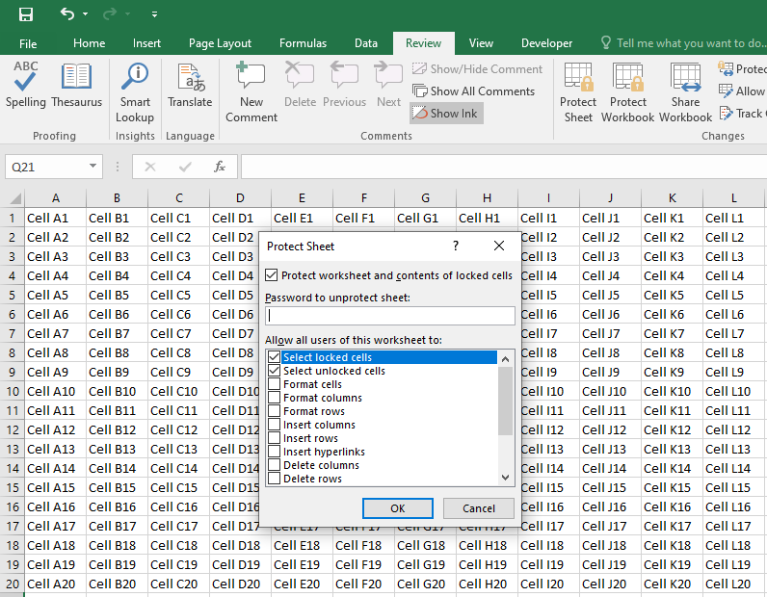

**Step 3:** Select the checkbox “Select Locked Cells” and “Select unlocked Cells” and then enter the password and confirm password and then click Ok button

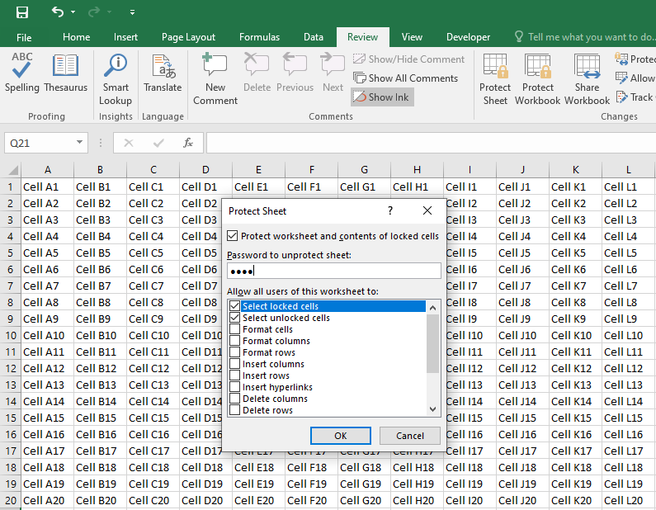

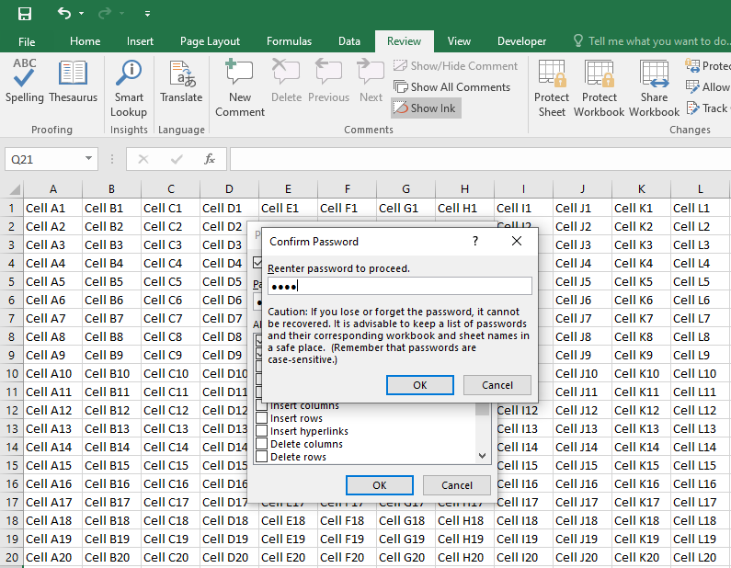

After successful enter the password, the “Protect Sheet” icon changed to “Unprotect Sheet”

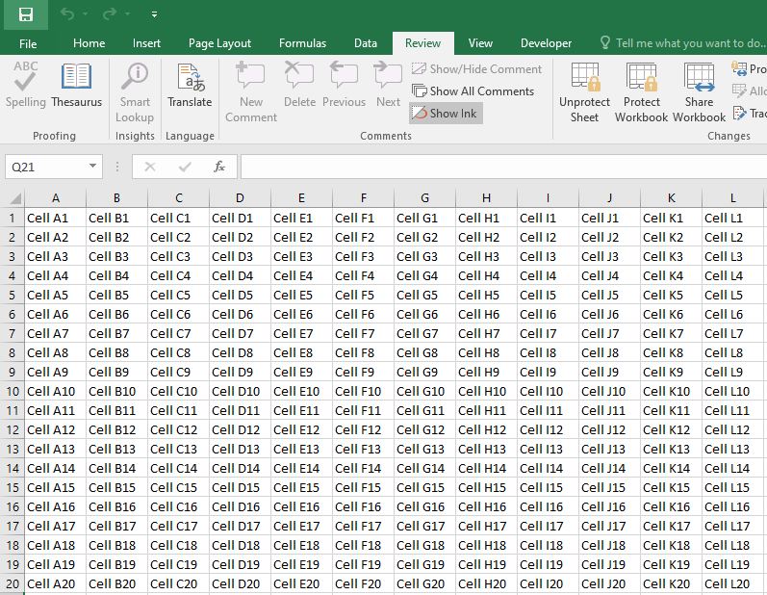

Copy any of the cell data and paste it in the sheet, it will throws an error as below.

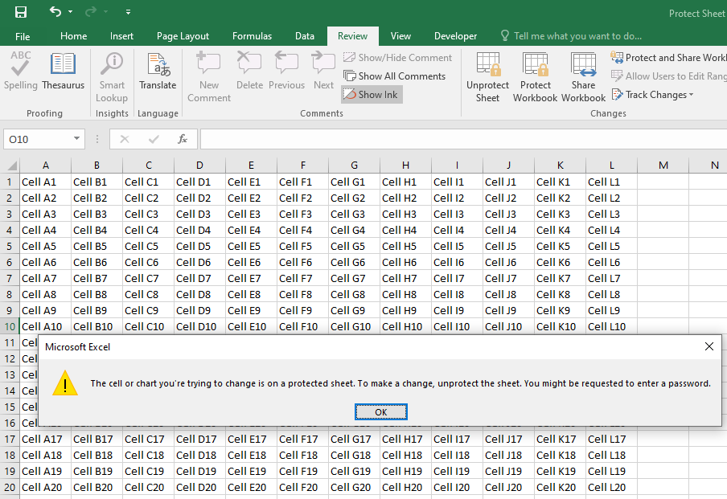

Users cannot make changes to locked cells.

3. How to move or copy the worksheet into another workbook?

**Solution:** Either to copy the worksheet in the same workbook or move to new work book following the below steps.

**Step 1:** Choose the sheet and right click on the sheet name

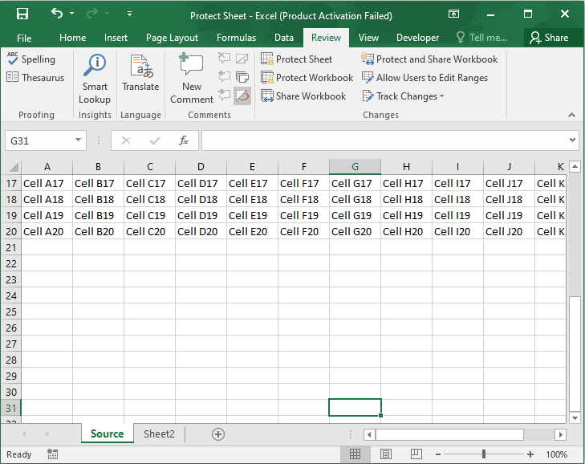

**Step 2:** Click on Move or Copy option

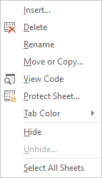

**Step 3:** To move the worksheet to a new workbook then choose the option to “(new book)”

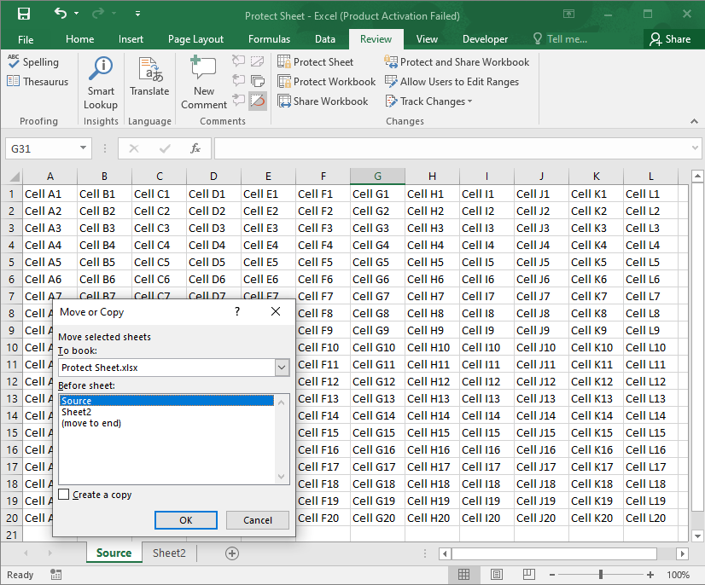

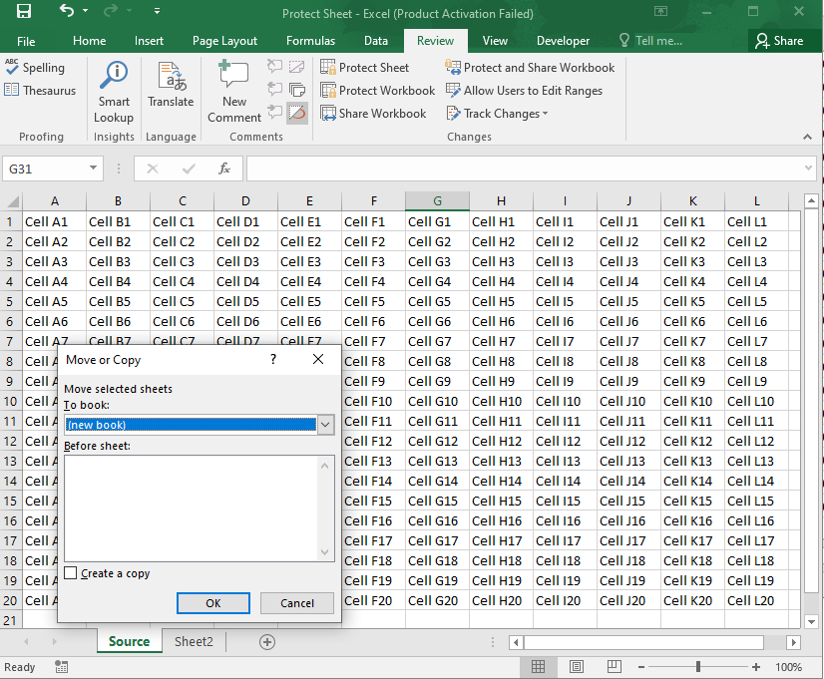

Worksheet moved to new workbook

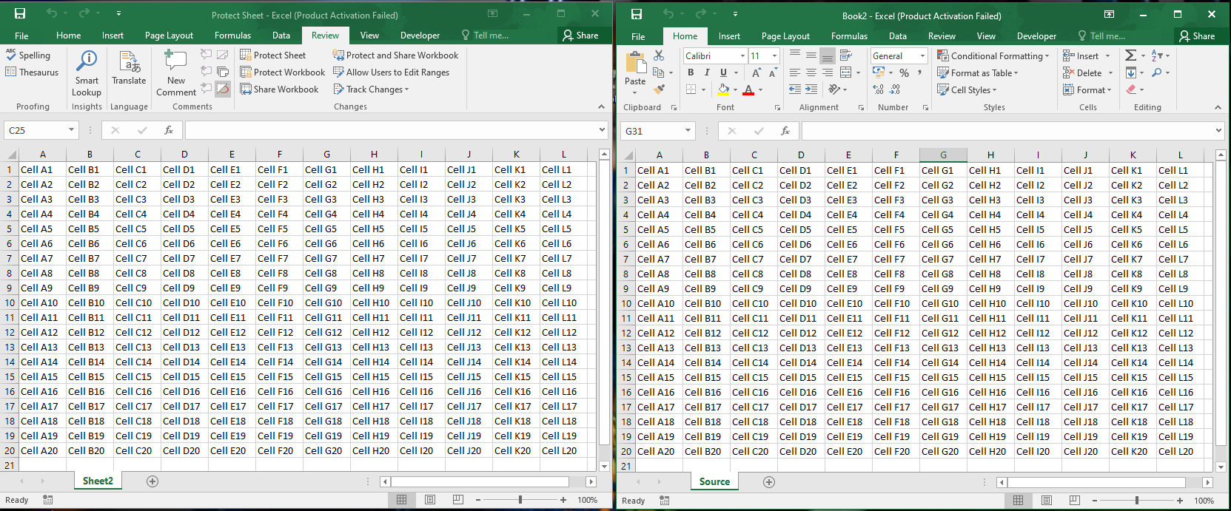

**Step 4:** To copy the worksheet choose the option “Create a Copy”. A duplicate version sheet is displayed in the same worksheet Source (2).

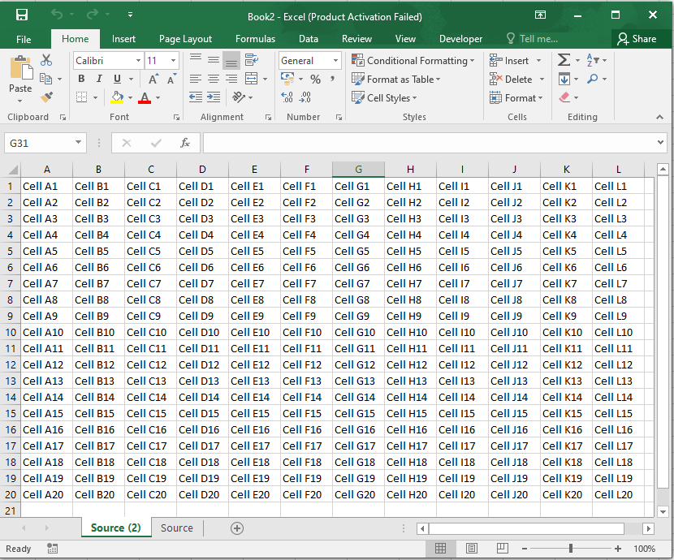

4. Which key is used as a shortcut for opening a new window document?

**Solution:**

1. Create a new workbook. Ctrl + N

Or

1. Click on **New** option from the quick access bar

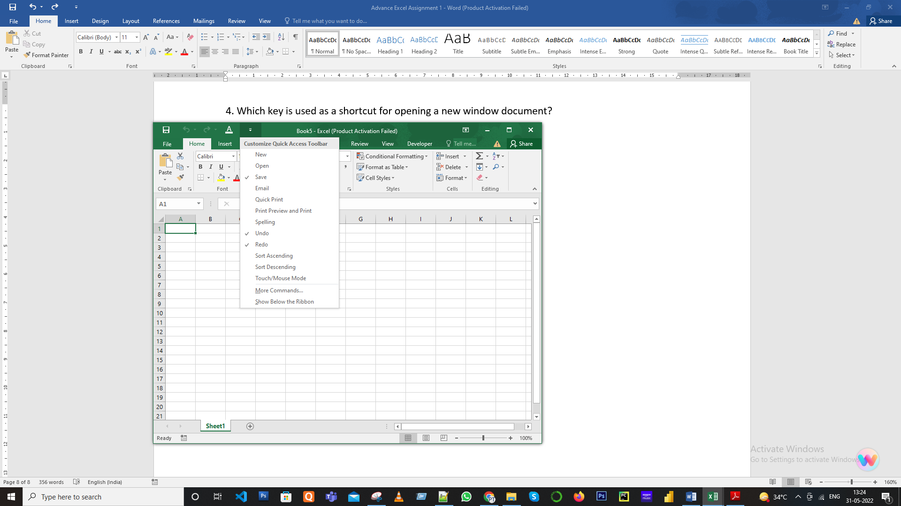

5. What are the things that we can notice after opening the Excel interface?

**Solution**:

The row and column rectangular grid described in Excel Spreadsheets is only part of the Excel user interface. The overall interface is as follows:

Workbook Title

Title Bar

Quick Access Bar

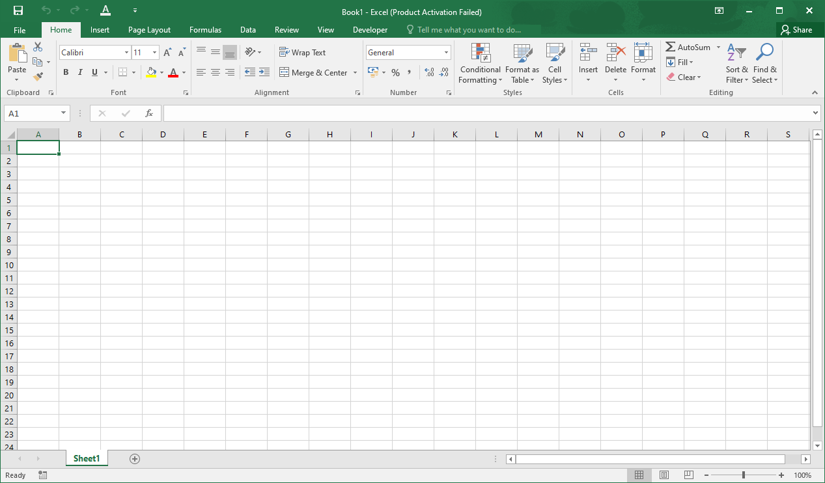

Formula Bar

Menu Tabs

Status Bar

Worksheet Name

Name Box

Active Cell

Horizontal Split Control

Vertical Split Control

6. When to use a relative cell reference in excel?

**Solution:**

* Relative references are **Excel's default cell references**.
* This is a combination of column names and row numbers without the dollar sign ($).
* When you copy a formula from one cell to another, the relative cell address changes depending on the relative position of the columns and rows.

B3,C3,D3,E3, etc. are examples of relative cell references. Relative references are used when you need to perform similar operations on multiple cells and you need to change the formula depending on the relative addresses of columns and rows.

Step 1: Select the cell F and Enter the Sum Formula

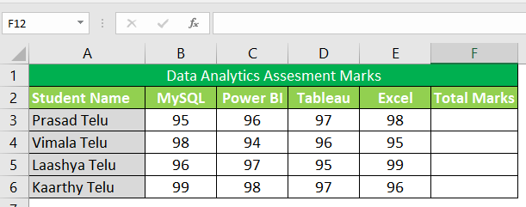

Step 2: Sum Formula =B3+C3+D3+E3

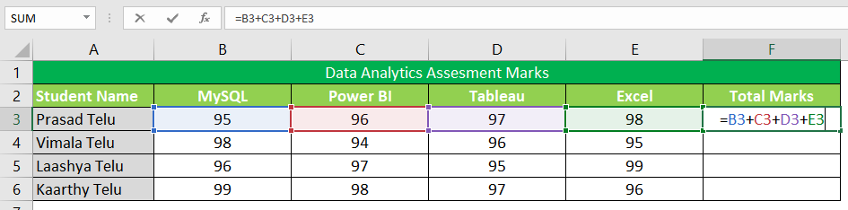

Step 3: Now click on the Fill handle at the corner of cell which contains the formula(F3)

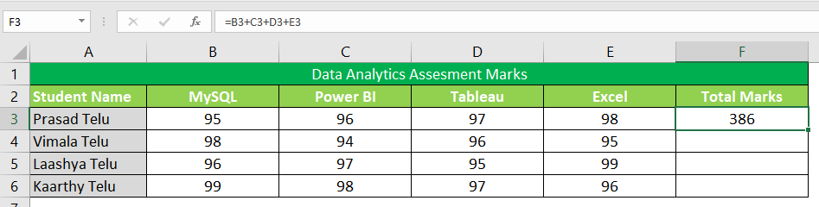

Step 4: Drag the Fill handle up to the cells you want to fill. In our example, we will drag it till cell F6.

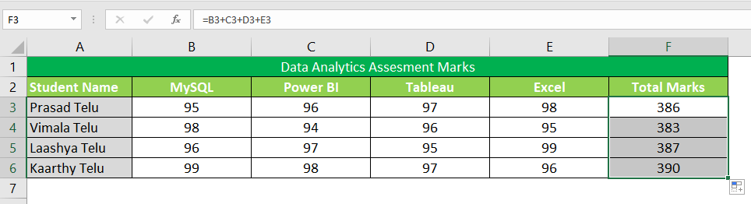

We can see that the relative address of cell B3 changes to B4, B5, B6 and so on, similarly the relative address changes for column B, depending on the relative position of the row.

